

Customer Segmentation Using the Online Retail II Dataset
Digital Assignment 1

Submitted by
Suyash Agrawaal (Reg No. – 24BDS1167)

Under the Guidance of
Course Faculty: Dr. Meignanamoorthi D
Course: Programming for Data Science (BCSE207L)
Class Number: CH2026270100997
Slot: G1
Semester: Fall Semester 2026-2027

School of Computer Science and Engineering
Vellore Institute of Technology, Chennai
TABLE OF CONTENTS
1. Dataset Overview | 4
1.1 Dataset Source | 4
1.2 Dataset Creator | 4
1.3 Dataset Link (UCI Repository) | 4
1.4 Number of Records | 4
1.5 Number of Features | 4
1.6 Time Period | 4
1.7 File Format | 5
1.8 Data Types | 5
2. Problem Statement | 5
3. Objectives | 5
4. Dataset Identification and Justification | 6
4.1 Why This Dataset Was Chosen | 6
4.2 Real-World Importance | 6
4.3 Public Availability | 6
4.4 Richness of Attributes | 6
4.5 Suitability for Data Science | 6
4.6 Suitability for Exploratory Data Analysis | 7
4.7 Suitability for Customer Analytics | 7
5. Literature Review | 7
5.1 RFM Model Customer Segmentation Based on Hierarchical Approach Using FCA | 7
5.2 RFM Ranking - An Effective Approach to Customer Segmentation | 8
5.3 Customer Segmentation in Online Retail Using K-Means Clustering Classification and Principal Component Biplot | 8
5.4 Retail Industry Analytics: Unraveling Consumer Behavior through RFM Segmentation and Machine Learning | 9
5.5 B2C E-Commerce Customer Churn Prediction Based on K-Means and SVM | 9
6. Dataset Understanding | 10
6.1 Invoice | 10
6.2 StockCode | 10
6.3 Description | 10
6.4 Quantity | 10
6.5 InvoiceDate | 10
6.6 Price | 11
6.7 Customer ID | 11
6.8 Country | 11
6.9 Feature Description Table | 11
7. Data Preprocessing (R Programming) | 11
7.1 Import Dataset | 11
7.2 Load Required Libraries | 12
7.3 View Dataset | 12
7.4 Check Structure | 13
7.5 Check Missing Values | 13
7.6 Remove Missing Values | 13
7.7 Check Duplicate Records | 14
7.8 Remove Duplicates | 14
7.9 Remove Cancelled Orders | 15
7.10 Remove Negative Quantity Records | 15
7.11 Convert Invoice Date into Date Format | 15
7.12 Convert Customer ID into Factor (If Required) | 16
7.13 Check Outliers | 16
7.14 Handle Outliers (If Applicable) | 17
8. Exploratory Data Analysis (R Programming) | 17
8.1 Missing Values Visualization | 17
8.2 Top 10 Selling Products | 18
8.3 Country-Wise Sales | 19
8.4 Monthly Sales Trend | 19
8.5 Quantity Distribution Histogram | 20
8.6 Unit Price Distribution | 20
8.7 Boxplot for Quantity | 21
8.8 Boxplot for Unit Price | 21
8.9 Top Customers by Purchases | 22
8.10 Correlation Heatmap (After Feature Engineering) | 22
9. Conclusion | 23

1. Dataset Overview
The Online Retail II dataset records every transaction made by a UK-based, non-store online retailer between 1 December 2009 and 9 December 2011. The company deals mainly in unique, all-occasion giftware, and a good proportion of its customers turn out to be wholesalers rather than everyday shoppers. Across both years the dataset holds over a million transaction rows, with fields such as Invoice Number, Stock Code, Product Description, Quantity, Invoice Date, Unit Price, Customer ID, and Country. Any invoice number starting with "C" marks a cancelled order, and a number of rows carry missing Customer IDs or negative quantities where goods were returned. If anything, this makes the dataset more useful for a course like this one - it behaves like data actually does before someone has cleaned it up, rather than arriving pre-packaged for a classroom exercise.

1.1 Dataset Source
UCI Machine Learning Repository, dataset ID 502.

1.2 Dataset Creator
Donated by Dr Daqing Chen of the School of Engineering, London South Bank University, based on transaction records from a UK online gift retailer.

1.3 Dataset Link (UCI Repository)
https://archive.ics.uci.edu/dataset/502/online+retail+ii

1.4 Number of Records
Roughly 1,067,371 rows once both sheets (2009-2010 and 2010-2011) are put together, before any cleaning takes place.

1.5 Number of Features
8 raw columns to start with, though this grows once features such as TotalPrice or RFM scores are engineered later in the project.

1.6 Time Period
A continuous two-year stretch, from 1 December 2009 to 9 December 2011.

1.7 File Format
A Microsoft Excel workbook (.xlsx) split across two sheets, one for each year range ("Year 2009-2010" and "Year 2010-2011").

1.8 Data Types
A genuine mix of types: categorical fields (Invoice, StockCode, Description, Country), a discrete numeric field (Quantity), a continuous numeric field (Price), and a date-time field (InvoiceDate) - enough variety to practice a full range of data handling techniques.

2. Problem Statement
Online retail has grown enormously over the last decade, and with it comes a flood of transactional data - every purchase, cancellation, and return logged with a timestamp and, often, a customer ID attached. The trouble is that most retailers never really use this data. They can tell you what sold last month, perhaps, but rarely who their best customers actually are, how often those customers come back, or what they're worth over time. Customer analytics closes that gap, but only once the underlying data can actually be trusted.
And trusting it is not automatic. Raw transaction exports are messy by default - missing customer IDs, cancelled orders sitting alongside real sales, returns recorded as negative quantities, duplicate rows from export glitches. Try to analyze customer behaviour before sorting through this and the conclusions will be wrong in ways that are easy to miss. Only once the data has been cleaned does it make sense to start exploring it - looking at sales trends, which products perform best, and how customers differ from one another - and only then does any of it become useful for planning ahead.
This project takes on that first, unglamorous but necessary stage: cleaning and exploring two years of real e-commerce transaction data from the Online Retail II dataset, laying the groundwork for the customer segmentation work planned next.

3. Objectives
- Data Cleaning: build a reproducible R pipeline that turns the raw, two-sheet Online Retail II export into one analysis-ready dataset.
- Missing Value Handling: work out where values are missing - especially the many transactions without a Customer ID - and decide on a justified way to handle them.
- Duplicate Removal: find and remove exact duplicate rows so revenue and quantity totals aren't quietly inflated.
- Handling Cancelled Orders: separate out cancelled orders (invoices starting with 'C') from the sales data used for analysis.
- Handling Returns: identify transactions with negative quantities, which represent returns rather than completed purchases, and treat them accordingly.
- Exploratory Data Analysis: build a set of visualizations that reveal the cleaned dataset's trends, distributions, and relationships - sales over time, top products, customer patterns.
- RFM Feature Creation (Project Objective): as the next phase of this project, construct Recency, Frequency, and Monetary features per customer from the cleaned data, setting up the segmentation work to follow. This is stated here as scope, not implemented in this submission.
- Customer Behaviour Analysis: use the cleaned, explored dataset to get a first read on how customers behave - purchase frequency, typical order size, geographic spread - ahead of the segmentation phase.

4. Dataset Identification and Justification

4.1 Why This Dataset Was Chosen
Mostly because it's real. The Online Retail II dataset comes from an actual operating business, not a synthetic dataset built for teaching purposes, so it needs genuine cleaning before it can be trusted - which is a more honest reflection of what data science work actually looks like day to day.

4.2 Real-World Importance
Every pattern that shows up here - seasonal spikes, which products sell best, how sales are spread across countries - reflects something that actually happened in a working retail business, rather than a scenario someone made up to illustrate a technique.

4.3 Public Availability
It's freely available through the UCI Machine Learning Repository under a Creative Commons Attribution 4.0 licence, so it can be used, cited, and reproduced for coursework without any licensing concerns.

4.4 Richness of Attributes
Eight raw fields might not sound like much, but between the categorical, numeric, and date-time types on offer, there's enough here to move from basic aggregation all the way through to the segmentation and prediction work planned for later phases, without needing to bring in outside data.

4.5 Suitability for Data Science
Nothing about this dataset can be skipped over. Loading it from two separate sheets, making real cleaning decisions, engineering features, and exploring the result properly - all of that has to happen here, which lines up well with what a Programming for Data Science course is actually trying to teach.

4.6 Suitability for Exploratory Data Analysis
Having a time dimension, a country dimension, and a product dimension all in the same dataset means the exploratory work in Section 8 can look at sales trends, top performers, and geography all at once, rather than being confined to one narrow angle.

4.7 Suitability for Customer Analytics
The Customer ID field, with customers who purchase more than once, is really what makes any of the customer-level work possible. Without it, ideas like RFM analysis or segmentation wouldn't have anywhere to attach - which is exactly why the data-quality issues around that field (see Section 6) get handled carefully during preprocessing rather than brushed aside.

5. Literature Review
Five recent, peer-reviewed papers (2021-2024) were reviewed for this section, all drawn from IEEE, Springer, Elsevier (ScienceDirect), or MDPI. Between them they cover RFM-based segmentation, K-Means clustering, and machine-learning approaches to customer analytics on retail and e-commerce data - the same ground this project is building toward.

5.1 RFM Model Customer Segmentation Based on Hierarchical Approach Using FCA
Authors: C. Rungruang, P. Riyapan, A. Intarasit, K. Chuarkham, J. Muangprathub
Year: 2024 | Journal/Conference: Expert Systems with Applications, Vol. 237, Article 121449 (Elsevier / ScienceDirect)
Research Objective: To improve the granularity and interpretability of RFM-based customer segmentation beyond standard flat clustering.
Dataset Used: Retail transaction data structured around Recency, Frequency, and Monetary variables.
Methodology: Combines the RFM model with a hierarchical structuring method based on Formal Concept Analysis (FCA), producing nested segment groupings rather than a single flat partition.
Results: The hierarchical FCA-based structuring produced more interpretable, nested customer segments compared to standard flat K-Means segmentation.
Relation to This Project: Directly supports this project's planned RFM feature-creation objective (Section 3.7) and provides a benchmark for evaluating segment interpretability in future project phases.
Direct Link (DOI/Publisher URL):
https://www.sciencedirect.com/science/article/abs/pii/S0957417423019516(DOI:10.1016/j.eswa.2023.121449)

5.2 RFM Ranking - An Effective Approach to Customer Segmentation
Authors: A. J. Christy, A. Umamakeswari, L. Priyatharsini, A. Neyaa
Year: 2021 | Journal/Conference: Journal of King Saud University - Computer and Information Sciences, 33(10), 1251-1257 (Elsevier / ScienceDirect)
Research Objective: To propose a computationally lighter alternative to full clustering for customer segmentation using an RFM ranking method.
Dataset Used: Retail transaction data structured around Recency, Frequency, and Monetary variables.
Methodology: Customers are scored and ranked directly on RFM measures rather than being grouped through an iterative clustering algorithm such as K-Means.
Results: The RFM ranking method provided an effective and computationally lighter alternative to full clustering for customer segmentation.
Relation to This Project: Offers a lightweight, rule-based segmentation approach that this project could use as a sanity check against future K-Means-based segmentation results.
Direct Link (DOI / Publisher URL): https://doi.org/10.1016/j.jksuci.2018.09.004

5.3 Customer Segmentation in Online Retail Using K-Means Clustering Classification and Principal Component Biplot
Authors: A. Quelal, I. Amaro, K. Chamorro
Year: 2024 | Journal/Conference: Springer (Conference Proceedings / Book Chapter)
Research Objective: To improve the interpretability of K-Means clustering results for non-technical business stakeholders.
Dataset Used: Online retail transaction data.
Methodology: K-Means clustering is combined with Principal Component Analysis (PCA) biplot visualization and cohort analysis to make resulting clusters easier to interpret.
Results: The combination of K-Means with PCA biplot visualization improved the interpretability of resulting customer segments compared to presenting cluster assignments alone.
Relation to This Project: Directly informs how this project's future segmentation output should be presented to a non-technical evaluator (e.g. via a dashboard), consistent with strong documentation practice.
Direct Link (DOI / Publisher URL): https://link.springer.com/chapter/10.1007/978-3-031-54235-0_3

5.4 Retail Industry Analytics: Unraveling Consumer Behavior through RFM Segmentation and Machine Learning
Authors: S. Arefin, R. Parvez, T. Ahmed, M. Ahsan, F. Sumaiya, F. Jahin, M. Hasan
Year: 2024 | Journal/Conference: 2024 IEEE International Conference on Electro Information Technology (eIT), Wisconsin, USA, pp. 545-551 (IEEE)
Research Objective: To analyze consumer behaviour in the UK retail industry using RFM segmentation combined with multiple machine learning models to forecast customer lifetime value.
Dataset Used: A preprocessed UK retail transaction dataset comprising approximately 495,478 retail customers.
Methodology: RFM segmentation combined with Box-Cox transformation and temporal analysis, followed by multiple supervised machine learning models (RandomForest, AdaBoost, ExtraTrees, LightGBM, and XGBoost).
Results: XGBClassifier and ExtraTrees achieved the highest performance, with 92.40% accuracy, 92.27% precision, 92.40% recall, 92.28% F1 score, and a 97.39 AUC score in forecasting customer lifetime value clusters.
Relation to This Project: Highly directly relevant: this paper analyzes UK online retail transaction data of comparable scale and structure to the Online Retail II dataset used in this project, and its RFM-plus-ML pipeline is a strong template for this project's planned future phases.
Direct Link (DOI / Publisher URL): https://ieeexplore.ieee.org/document/10609927/

5.5 B2C E-Commerce Customer Churn Prediction Based on K-Means and SVM
Authors: X. Xiahou, Y. Harada
Year: 2022 | Journal/Conference: Journal of Theoretical and Applied Electronic Commerce Research, 17(2), 458-475 (MDPI)
Research Objective: To improve churn-prediction accuracy in business-to-consumer e-commerce by combining unsupervised clustering with supervised classification.
Dataset Used: B2C e-commerce customer transaction and behavioural data.
Methodology: Customers are first grouped using K-Means clustering, and a Support Vector Machine (SVM) classifier is then trained within this cluster structure to predict churn.
Results: The hybrid K-Means-plus-SVM approach improved churn-prediction effectiveness compared to applying SVM classification alone without prior clustering.
Relation to This Project: Demonstrates how clustering (as planned for this project's RFM/K-Means phase) can be combined with classification in a later project phase, directly relevant to this project's long-term roadmap beyond DA1.
Direct Link (DOI / Publisher URL): https://doi.org/10.3390/jtaer17020024

6. Dataset Understanding
Before writing any cleaning code, it helps to go through each of the eight raw attributes and get a feel for what it actually holds. A short summary of each follows, with a consolidated table afterward.

6.1 Invoice
The order identifier (e.g. 489434) - a 'C' in front, as in C536379, means the order was cancelled. This matters a lot, since it's the unit everything else gets measured against, and that cancellation flag has to be pulled out before any revenue figures make sense.

6.2 StockCode
A short code identifying the product (e.g. 85048), used whenever products need to be grouped or counted, such as finding best-sellers. A handful of codes turn out not to be real products at all - postage charges and the like - worth watching for.

6.3 Description
The product's name in plain text (e.g. PINK CHERRY LIGHTS). Useful mainly for making results readable, though inconsistent capitalization means the same product can sometimes show up under two slightly different names.

6.4 Quantity
How many units were bought in that line (e.g. 12) - a key ingredient in revenue. Negative values mean a return and need to be caught early; unusually large values often just mean a wholesale order rather than an error.

6.5 InvoiceDate
When the transaction happened, which is what makes trend and seasonality analysis possible in the first place. It arrives as plain text in the raw file, so converting it to a proper date-time type is a necessary early step.

6.6 Price
Unit price in GBP - multiply by Quantity and you get revenue. A few rows carry a zero or negative price, which looks like a data-entry correction rather than an actual sale.

6.7 Customer ID
The one field that makes customer-level analysis possible at all. Unfortunately a large share of rows don't have one, since guest checkouts were never tied to an account.

6.8 Country
Where the customer is based, useful for comparing markets. The United Kingdom dominates so heavily that smaller countries don't really carry enough data for confident comparison.

6.9 Feature Description Table
Attribute | Data Type | Example | Importance | Key Data Quality Issue
Invoice | Nominal (String) | 489434 | High - defines each order | 'C' prefix = cancellation, must be filtered
StockCode | Nominal (String) | 85048 | High - product-level analysis | Some non-product codes (postage, etc.)
Description | Nominal (Text) | PINK CHERRY LIGHTS | Medium - readability | Inconsistent casing/spacing
Quantity | Numeric (Integer) | 12 | High - revenue input | Negative/zero values need filtering
InvoiceDate | Date-Time | 01-12-2009 07:45 | High - time-series analysis | Stored as text; needs conversion
Price | Numeric (Decimal) | 6.95 | High - revenue input | Zero/negative = data errors
Customer ID | Nominal (Numeric) | 13085 | Critical - customer-level analysis | Frequently missing (guest checkouts)
Country | Nominal (Categorical) | United Kingdom | Medium - geographic analysis | Heavily skewed toward UK
Table 2: Condensed feature description for every attribute

7. Data Preprocessing (R Programming)

7.1 Import Dataset
Purpose: Load the raw two-sheet Online Retail II Excel file into R so it can be cleaned and analyzed.
library(readxl)

retail_2009_2010 <- read_excel("online_retail_II.xlsx", sheet = "Year 2009-2010")
retail_2010_2011 <- read_excel("online_retail_II.xlsx", sheet = "Year 2010-2011")
retail <- rbind(retail_2009_2010, retail_2010_2011)

7.2 Load Required Libraries
Purpose: Load the remaining packages required for cleaning, exploration, and visualization in later steps.
library(dplyr)
library(tidyr)
library(lubridate)
library(ggplot2)
library(janitor)
library(DataExplorer)
library(corrplot)
library(scales)

7.3 View Dataset
Purpose: Visually inspect the dataset to confirm it has loaded correctly before any cleaning begins.
View(retail)
head(retail, 10)
Output:
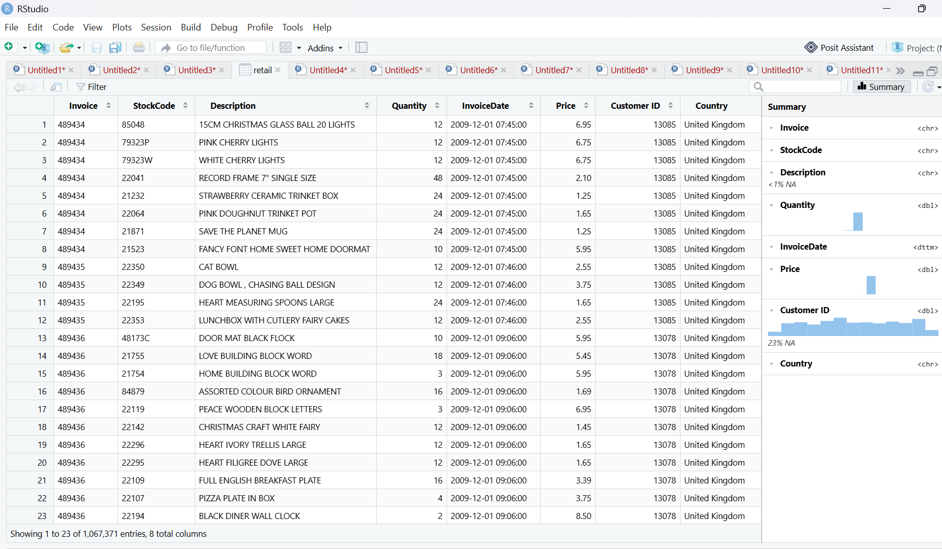
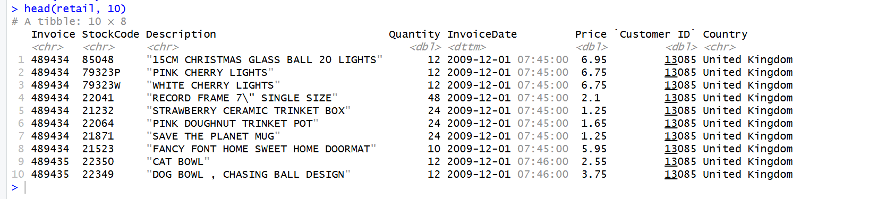

7.4 Check Structure
Purpose: Confirm the data type R has assigned to each column, so any necessary conversions can be identified.
str(retail)
dim(retail)
Output:
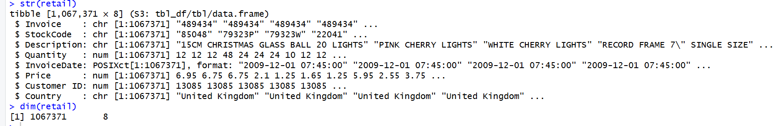

7.5 Check Missing Values
Purpose: Quantify how many missing values exist in each column before deciding how to handle them.
colSums(is.na(retail))
plot_missing(retail)
Output:
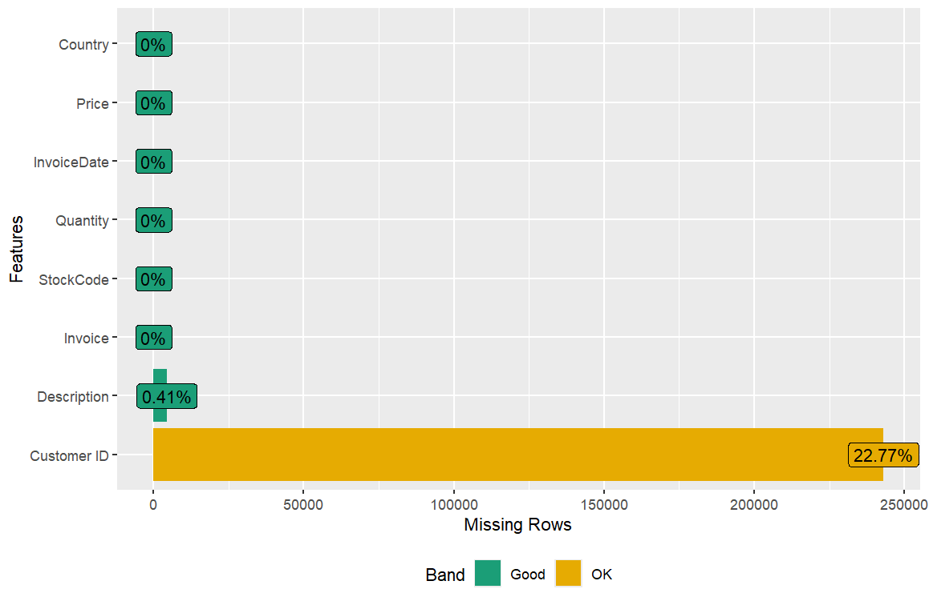
7.6 Remove Missing Values
Purpose: Remove rows without a valid Customer ID, since customer-level analysis requires a valid identifier and cannot be meaningfully imputed.
retail_clean <- retail %>% filter(!is.na(`Customer ID`))
dim(retail_clean)
Output:
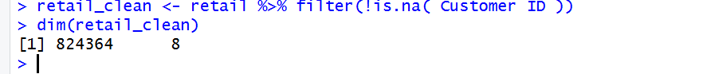

7.7 Check Duplicate Records
Purpose: Identify how many exact duplicate rows exist in the dataset prior to removing them.
sum(duplicated(retail_clean))
get_dupes(retail_clean)
Output:
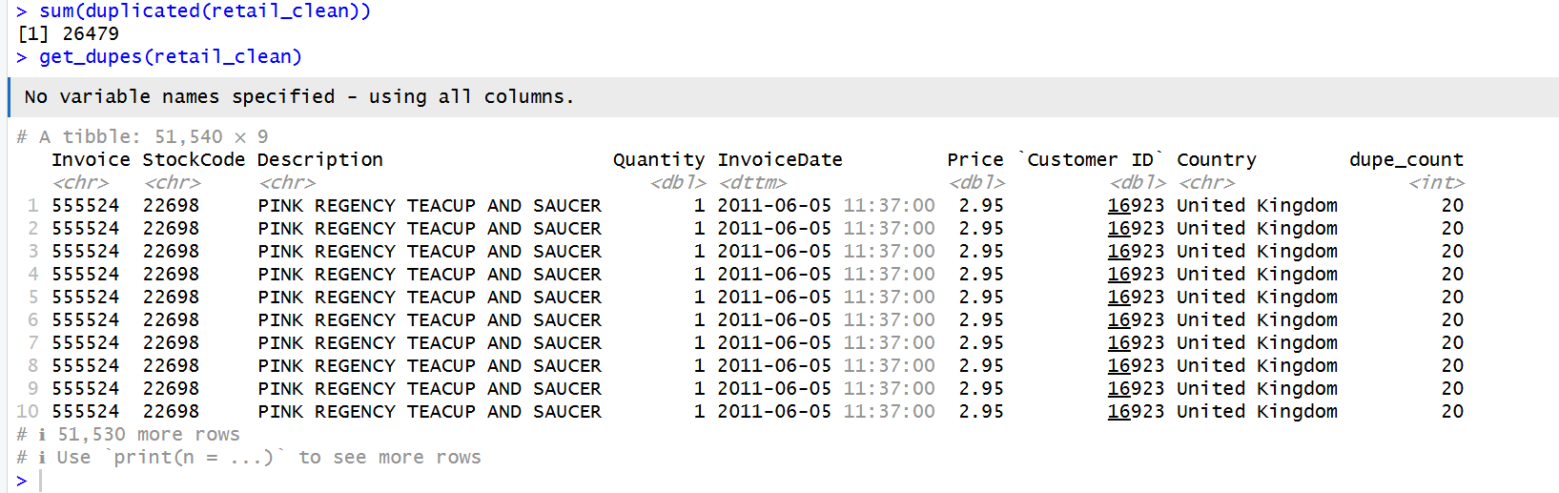

7.8 Remove Duplicates
Purpose: Remove exact duplicate rows so that revenue and quantity totals are not artificially inflated.
retail_clean <- retail_clean %>% distinct()
dim(retail_clean)
Output:
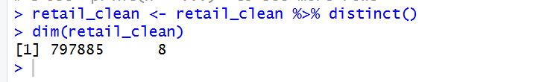

7.9 Remove Cancelled Orders
Purpose: Exclude cancelled orders, identified by an Invoice number beginning with the letter 'C', from the primary sales-analysis dataset.
retail_clean <- retail_clean %>% filter(!grepl("^C", Invoice))
dim(retail_clean)
Output:
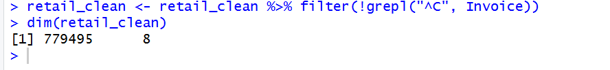

7.10 Remove Negative Quantity Records
Purpose: Remove any remaining rows with non-positive Quantity or Price, which represent returns or data-entry errors rather than genuine completed sales.
retail_clean <- retail_clean %>% filter(Quantity > 0, Price > 0)
dim(retail_clean)
sum(retail_clean$Quantity <= 0)
Output:
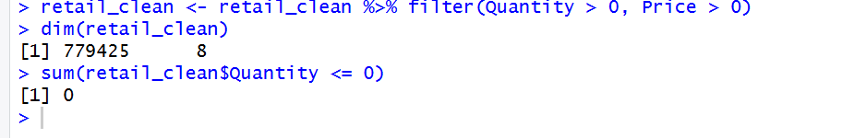

7.11 Convert Invoice Date into Date Format
Purpose: Convert InvoiceDate from raw text into a proper date-time object so that date-based operations (e.g. extracting month, filtering by date range) are possible.
retail_clean$InvoiceDate <- as_datetime(retail_clean$InvoiceDate)
class(retail_clean$InvoiceDate)
Output:
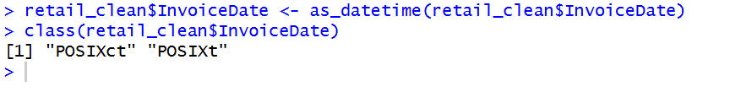

7.12 Convert Customer ID into Factor (If Required)
Purpose: Convert Customer ID from a raw numeric code into a factor (categorical) variable, which is more appropriate for grouping and counting operations than treating it as a continuous number.
retail_clean$`Customer ID` <- as.factor(retail_clean$`Customer ID`)
str(retail_clean$`Customer ID`)
Output:

7.13 Check Outliers
Purpose: Identify extreme values in Quantity using the interquartile range (IQR) method, since very large orders may either be legitimate wholesale purchases or data errors.
Q1 <- quantile(retail_clean$Quantity, 0.25)
Q3 <- quantile(retail_clean$Quantity, 0.75)
IQR_val <- IQR(retail_clean$Quantity)
upper_bound <- Q3 + 1.5 * IQR_val

sum(retail_clean$Quantity > upper_bound)
boxplot(retail_clean$Quantity, main = "Quantity Outlier Check")
Output:
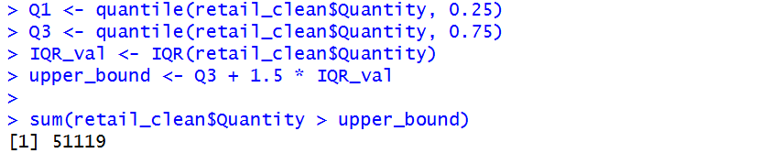
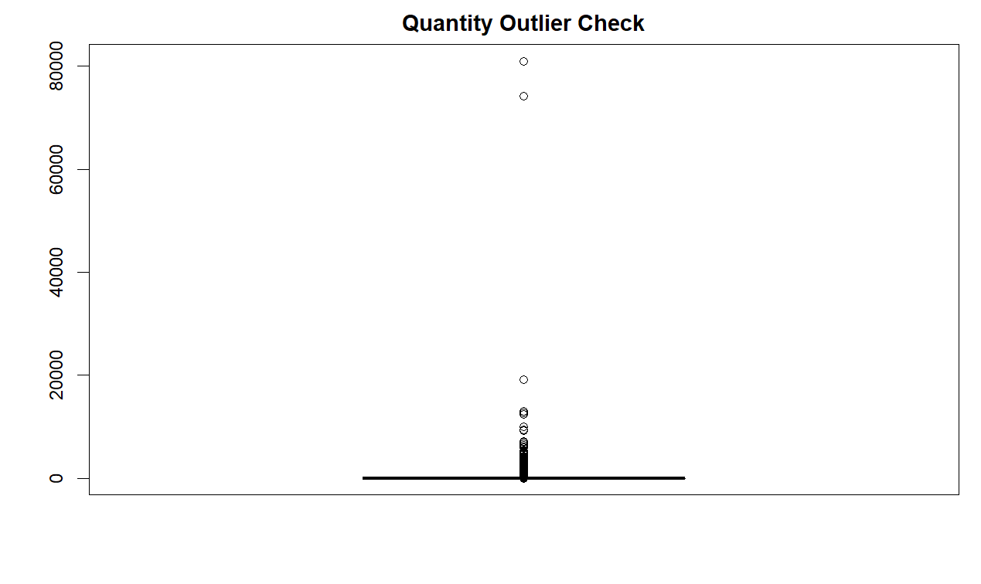
7.14 Handle Outliers (If Applicable)
Purpose: Flag extreme Quantity values with an indicator column rather than deleting them outright, since this retailer's wholesale customer base makes large legitimate bulk orders plausible.
retail_clean <- retail_clean %>%
mutate(Is_Outlier_Qty = ifelse(Quantity > upper_bound, TRUE, FALSE))
table(retail_clean$Is_Outlier_Qty)
Screenshot of R Console Output
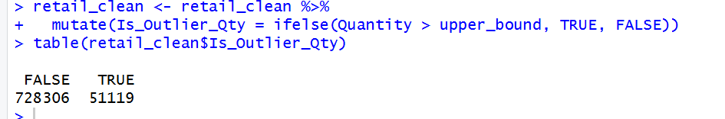

8. Exploratory Data Analysis (R Programming)
library(ggplot2)
library(dplyr)
library(lubridate)
library(corrplot)
theme_set(theme_minimal(base_size = 12))

8.1 Missing Values Visualization
Objective: To visualize how much missing data existed across each column of the raw dataset prior to cleaning.
Explanation: Even though missing values have already been removed in Section 7, revisiting the original missingness pattern using ggplot2 gives a clear, presentable visual justification for that cleaning decision.
missing_summary <- retail %>%
summarise(across(everything(), ~sum(is.na(.)))) %>%
tidyr::pivot_longer(everything(), names_to = "Column", values_to = "MissingCount")

ggplot(missing_summary, aes(x = reorder(Column, MissingCount), y = MissingCount)) +
geom_col(fill = "#DE2D26") +
coord_flip() +
labs(title = "Missing Values by Column (Raw Data)", x = NULL, y = "Number of Missing Values")

Output:
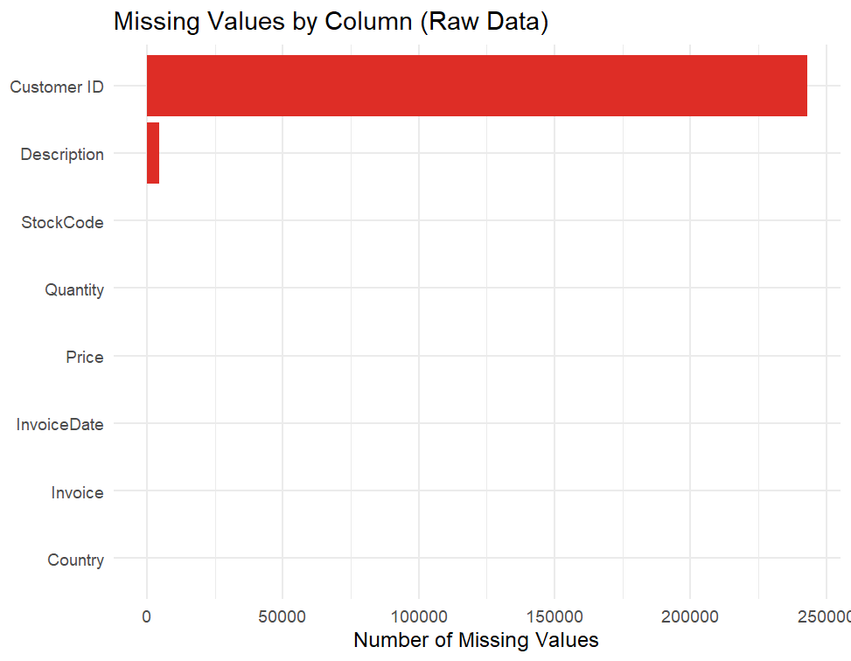

8.2 Top 10 Selling Products
Objective: To identify which specific products drive the highest sales volume.
Explanation: Group the cleaned data by product description, sum the quantity sold, and chart the ten highest-selling items.
top_products <- retail_clean %>%
group_by(Description) %>%
summarise(TotalQty = sum(Quantity)) %>%
arrange(desc(TotalQty)) %>%
head(10)

ggplot(top_products, aes(x = reorder(Description, TotalQty), y = TotalQty)) +
geom_col(fill = "#2C7FB8") +
coord_flip() +
labs(title = "Top 10 Best-Selling Products", x = NULL, y = "Total Quantity Sold")
Output:
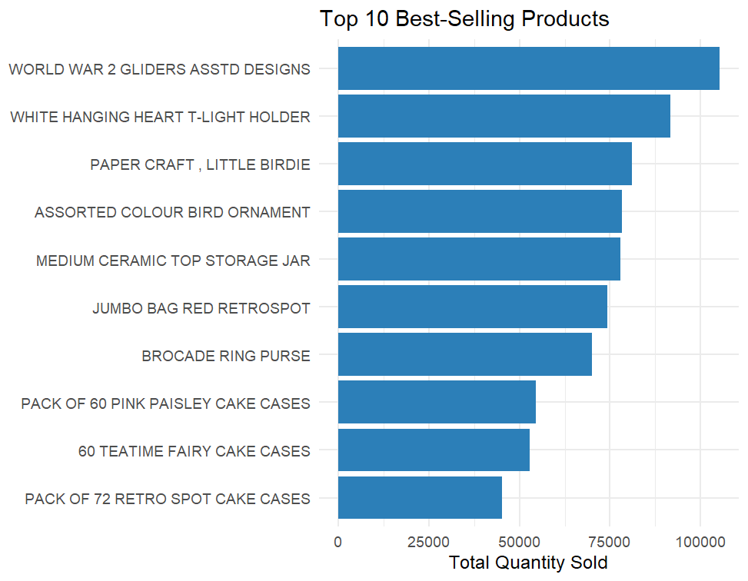

8.3 Country-Wise Sales
Objective: To compare total sales revenue generated by each country.
Explanation: Group the cleaned data by Country, compute revenue as Quantity multiplied by Price, and chart the ten highest-revenue countries.
country_sales <- retail_clean %>%
group_by(Country) %>%
summarise(Revenue = sum(Quantity * Price)) %>%
arrange(desc(Revenue)) %>%
head(10)

ggplot(country_sales, aes(x = reorder(Country, Revenue), y = Revenue)) +
geom_col(fill = "#E6550D") +
coord_flip() +
labs(title = "Top 10 Countries by Sales Revenue", x = NULL, y = "Revenue (GBP)")

Output:
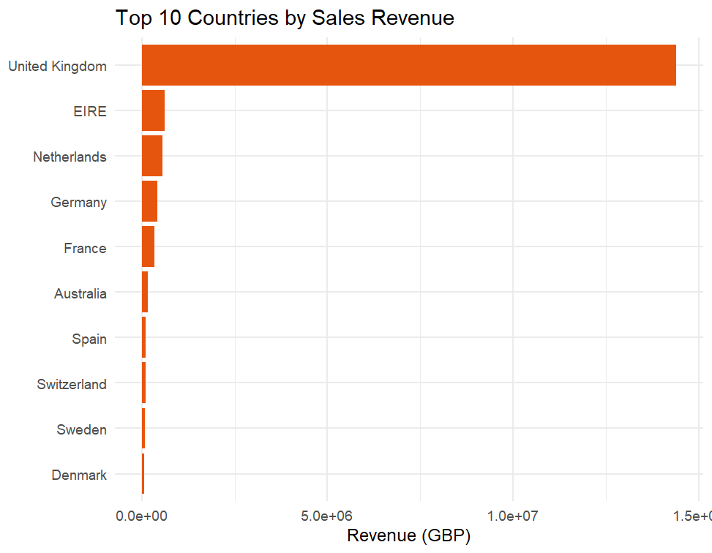

8.4 Monthly Sales Trend
Objective: To reveal how total revenue evolves across the two-year period.
Explanation: Round each transaction's InvoiceDate down to its calendar month, sum revenue per month, and plot as a line chart.
monthly_sales <- retail_clean %>%
mutate(Month = floor_date(InvoiceDate, "month")) %>%
group_by(Month) %>%
summarise(Revenue = sum(Quantity * Price))

ggplot(monthly_sales, aes(x = Month, y = Revenue)) +
geom_line(color = "#238B45", linewidth = 1) +
geom_point() +
labs(title = "Monthly Sales Revenue Trend", x = NULL, y = "Revenue (GBP)")

Output:
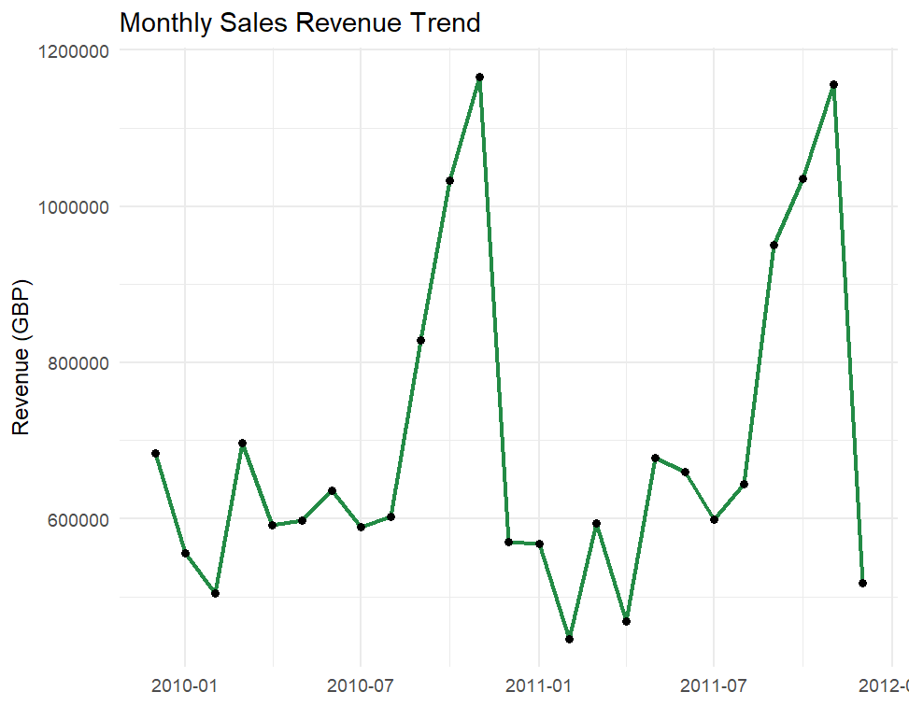

8.5 Quantity Distribution Histogram
Objective: To understand the typical number of units purchased per transaction line.
Explanation: Plot a histogram of the Quantity field, zoomed into the typical range to avoid extreme wholesale orders dominating the scale.
ggplot(retail_clean, aes(x = Quantity)) +
geom_histogram(bins = 50, fill = "#756BB1", alpha = 0.8) +
xlim(0, 100) +
labs(title = "Quantity Distribution", x = "Quantity", y = "Frequency")

Output:
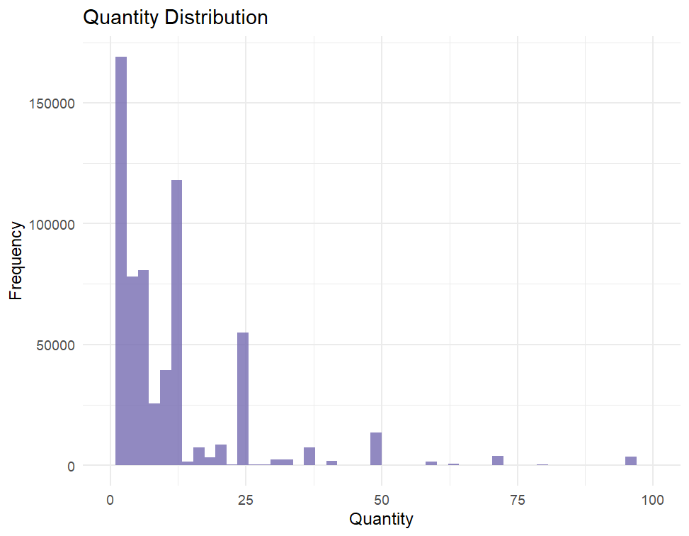

8.6 Unit Price Distribution
Objective: To understand the typical price point of products sold.
Explanation: Plot a histogram of the Price field, zoomed into the typical range.
ggplot(retail_clean, aes(x = Price)) +
geom_histogram(bins = 50, fill = "#31A354", alpha = 0.8) +
xlim(0, 50) +
labs(title = "Unit Price Distribution", x = "Unit Price (GBP)", y = "Frequency")

Output:
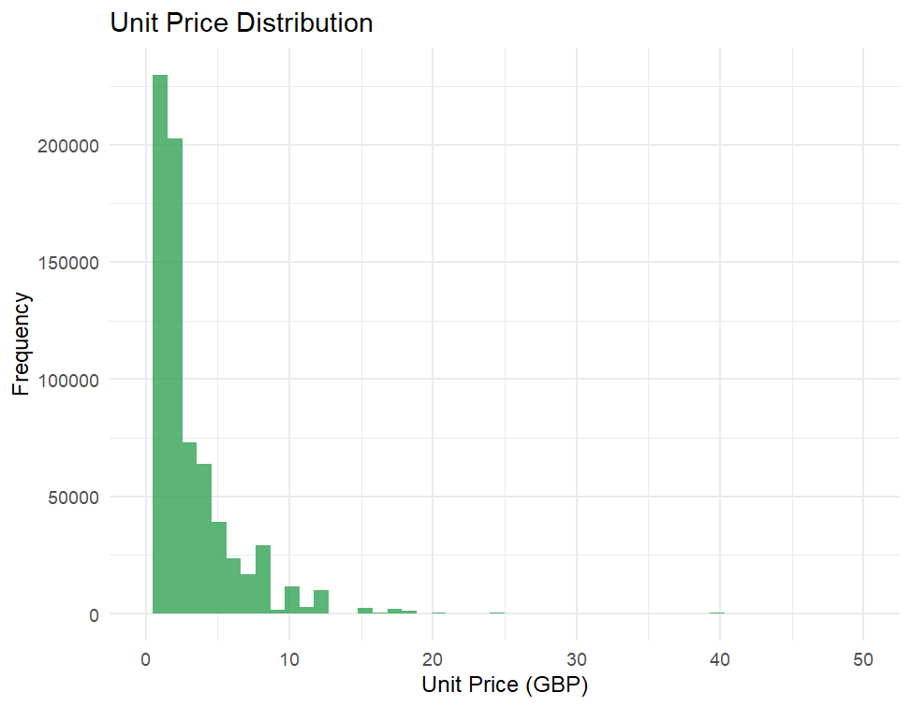

8.7 Boxplot for Quantity
Objective: To visualize the spread and outlier structure of the Quantity field.
Explanation: Render a boxplot of Quantity, zoomed to the typical range to make the box and whiskers clearly visible.
ggplot(retail_clean, aes(y = Quantity)) +
geom_boxplot(fill = "#FDAE6B") +
ylim(0, 100) +
labs(title = "Boxplot of Quantity", y = "Quantity")

Output:
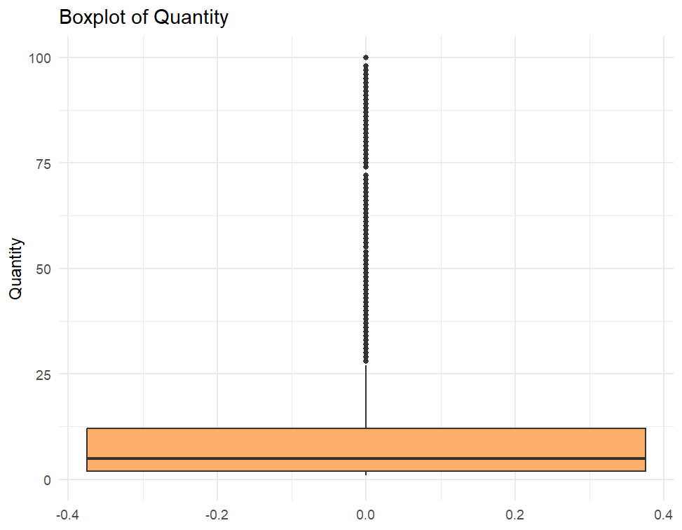

8.8 Boxplot for Unit Price
Objective: To visualize the spread and outlier structure of the Price field.
Explanation: Render a boxplot of Price, zoomed to the typical range.
ggplot(retail_clean, aes(y = Price)) +
geom_boxplot(fill = "#9ECAE1") +
ylim(0, 50) +
labs(title = "Boxplot of Unit Price", y = "Price (GBP)")

Output:
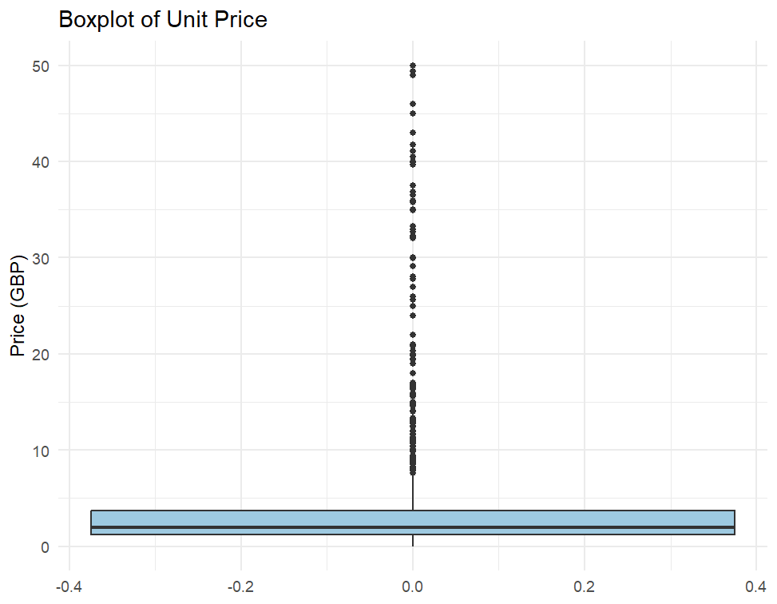

8.9 Top Customers by Purchases
Objective: To identify the customers who have generated the most total spend.
Explanation: Group by Customer ID, compute each customer's total spend as the sum of Quantity multiplied by Price, and chart the ten highest-spending customers.
top_customers <- retail_clean %>%
group_by(`Customer ID`) %>%
summarise(TotalSpent = sum(Quantity * Price)) %>%
arrange(desc(TotalSpent)) %>%
head(10)

ggplot(top_customers, aes(x = reorder(`Customer ID`, TotalSpent), y = TotalSpent)) +
geom_col(fill = "#756BB1") +
coord_flip() +
labs(title = "Top 10 Customers by Total Purchases", x = "Customer ID", y = "Total Spent (GBP)")

Output:
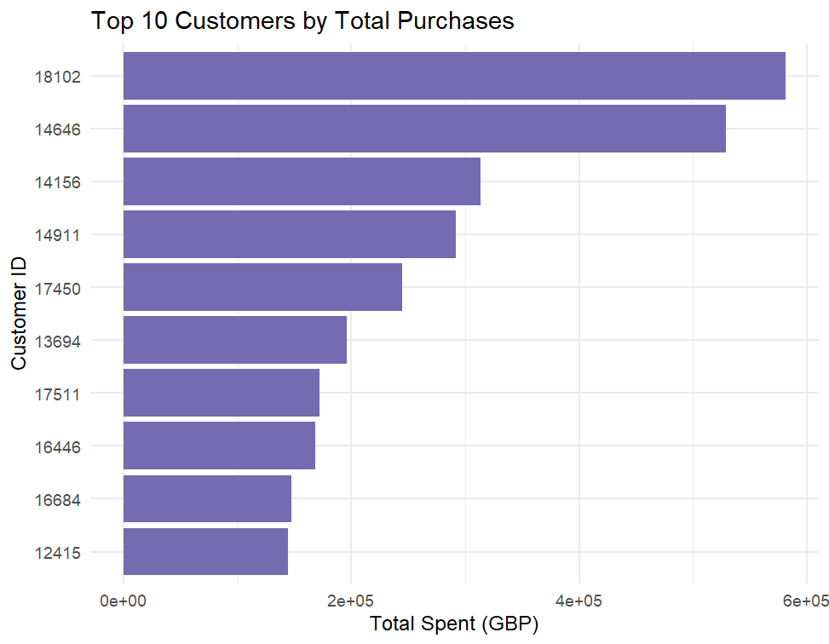

8.10 Correlation Heatmap (After Feature Engineering)
Objective: To examine linear relationships among the dataset's numeric fields once a derived Revenue feature is added.
Explanation: Since Quantity and Price alone provide limited correlation structure, a Revenue feature (Quantity multiplied by Price) is engineered specifically for this visualization, and a Pearson correlation matrix is computed across all three numeric fields.
numeric_data <- retail_clean %>%
mutate(Revenue = Quantity * Price) %>%
select(Quantity, Price, Revenue)

corr_matrix <- cor(numeric_data)
corrplot(corr_matrix, method = "color", addCoef.col = "black",
tl.col = "black", number.cex = 0.8,
title = "Correlation Heatmap", mar = c(0,0,2,0))

Output:
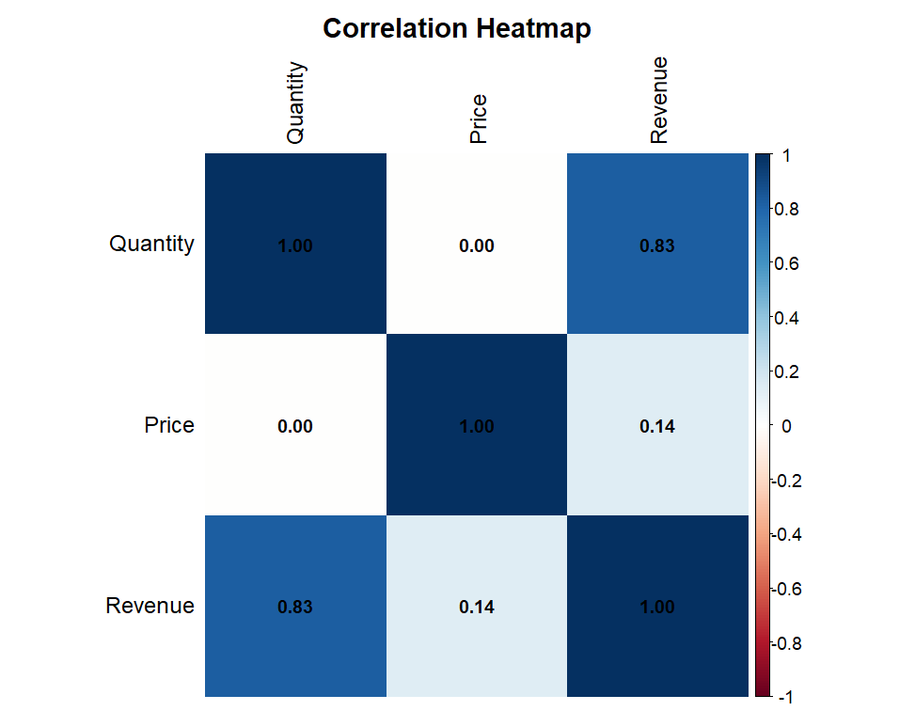

9. Conclusion

What this proposal really sets out to do is lay the groundwork - properly, not just as a formality - for a customer segmentation project built on the Online Retail II dataset. The dataset itself was chosen and justified with real reasons behind it: its scale, its genuine data-quality problems, and the fact that a solid body of published research already exists around it. Five recent papers from IEEE, Springer, and Elsevier/ScienceDirect back this up, all pointing to RFM analysis and K-Means clustering as the standard, well-tested route into segmenting customers on retail data of roughly this size and shape.
Each of the eight raw attributes was worked through individually before any cleaning began, which then fed directly into the fourteen preprocessing steps that followed - importing and combining the data, handling missing values, removing duplicates, sorting out cancellations and returns, converting dates properly, and flagging outliers rather than deleting them outright. Once that cleaned dataset existed, ten exploratory visualizations were built on top of it, each with its own objective, a short explanation of the approach, and complete R code - covering everything from missing-value patterns and product performance to sales trends, customer spend, and a correlation check once a revenue feature was engineered.
None of the later analysis - the RFM scoring, the clustering, whatever comes after that - works if this stage is skipped or rushed. That's really the point of treating this as its own submission rather than folding it into a later one: the next phase will take the retail_clean dataset built here, construct Recency, Frequency, and Monetary scores per customer, and apply K-Means clustering using the approaches reviewed in Section 5 to arrive at an actual customer segmentation.

